GERMAN LONGHAIRED POINTER CLUB

SPRING POINTING TEST
AND
GROUND TREATMENT TRAINING DAY
7th & 8th April 2026

Entries close 1st April 2026.

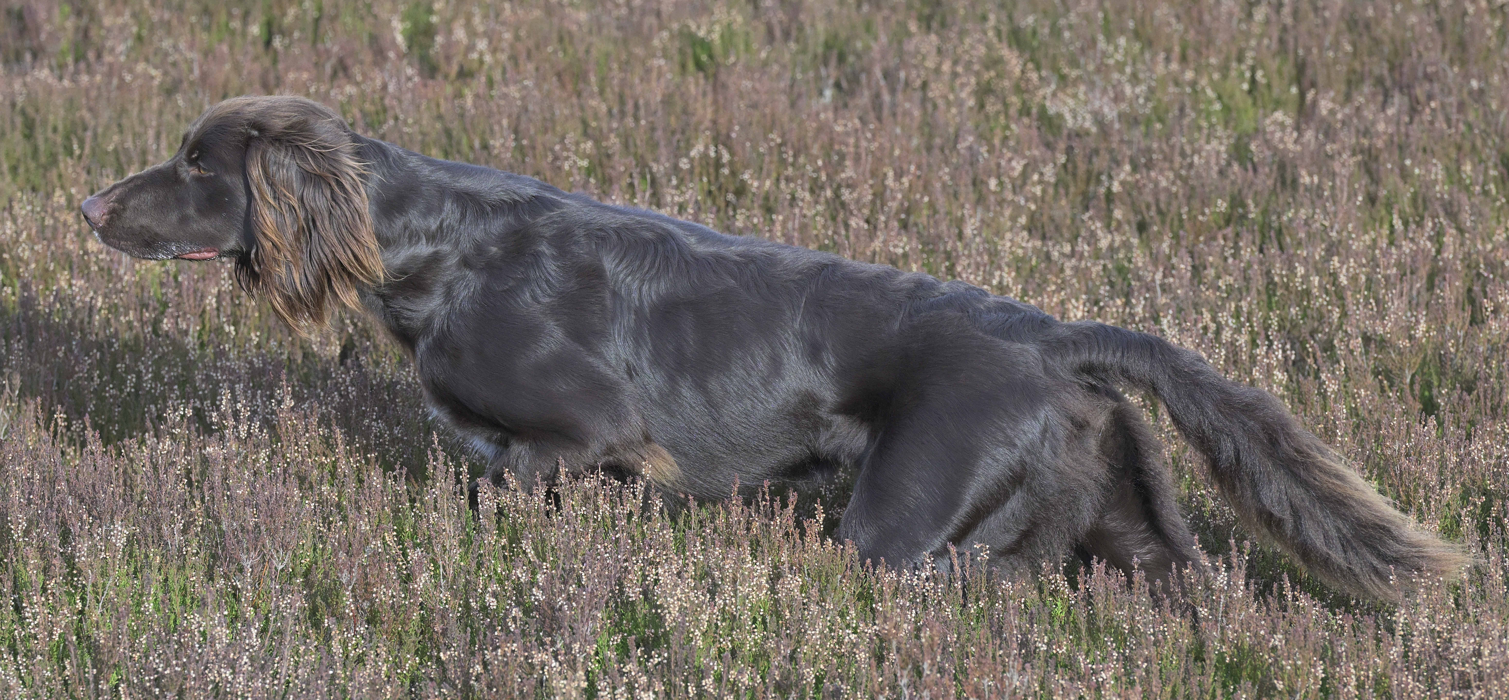

TRAINING DAY
The GLPC will be hosting a ground and wind treatment training day at Six Mile Bottom, Cambridgeshire, on Tuesday 7th April 2026.
Trainers: Annie Jones and Howard Kirby
Cost: £55 for members and £60 for non-members
Open to all levels
Limited to 10 places

SPRING POINTING TEST
The GLPC Spring Pointing Test will be held on Wednesday 8th April 2026 at Six Mile Bottom, Cambridgeshire.
Graders: Rory Major & TBC
Cost: £20 for members and £25 for non-members
Maximum of 18 dogs
Junior: For dogs over 6 months and under 2 years of age as of 1st January 2026
Adult: For dogs over 2 years of age on 1st January 2026

Please email FTSec@GLPClub.org.uk for an entry form.

